MI problems

1. 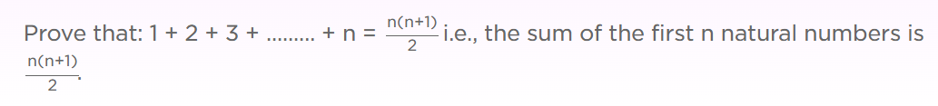
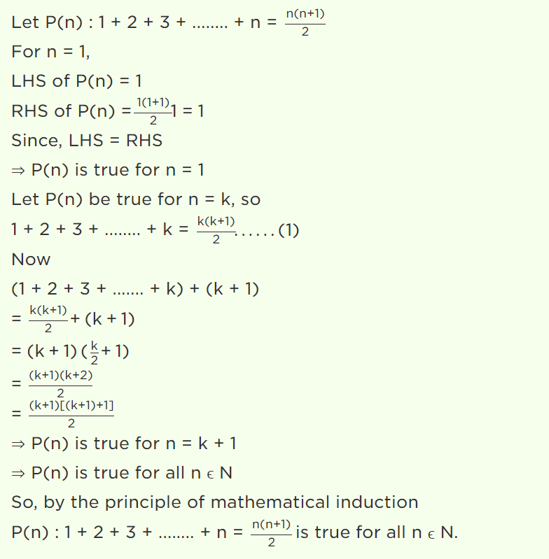

2. Problem: For any natural number n , 1² + 2² + ... + n² = n( n + 1 )( 2n + 1 )/6.
Proof:
Basis Step: If n = 0, then LHS = 0² = 0, and RHS = 0 * (0 + 1)(2*0 + 1)/6 = 0 .
Hence LHS = RHS.
Induction: Assume that for an arbitrary natural number n,
1² + 2² + ... + n² = n( n + 1 )( 2n + 1 )/6. -------- Induction Hypothesis
To prove this for n+1, first try to express LHS for n+1 in terms of LHS for n, and use the induction hypothesis.
Here let us try
LHS for n + 1 = 1² + 2² + ... + n² + (n + 1)² = ( 1² + 2² + ... + n² ) + (n + 1)²
Using the induction hypothesis, the last expression can be rewritten as
n( n + 1 )( 2n + 1 )/6 + (n + 1)²
Factoring (n + 1)/6 out, we get
( n + 1 )( n( 2n + 1 ) + 6 ( n + 1 ) )/6
= ( n + 1 )( 2n² + 7n + 6 )/6
= ( n + 1 )( n + 2 )( 2n + 3 )/6 ,
which is equal to the RHS for n+1.
Thus LHS = RHS for n+1.

3. Prove the following by using the principle of mathematical induction for all n∈N:

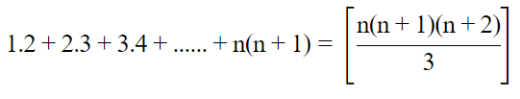
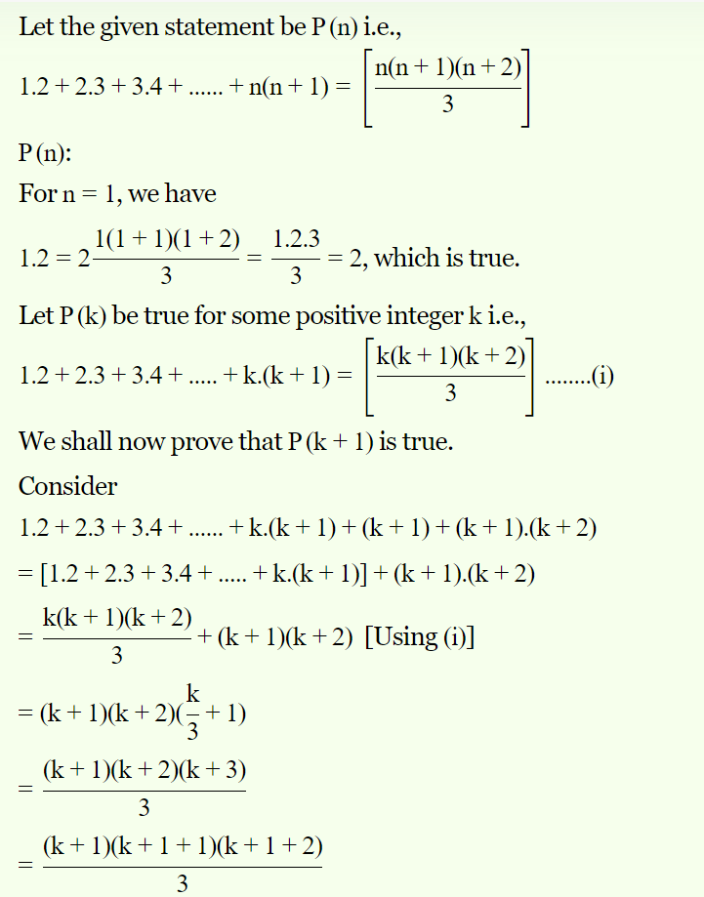

Thus, P(k+1) is true whenever P(k) is true.
Hence by the principle of mathematical induction, statement P(n) is true for all natural numbers i.e., n

4.
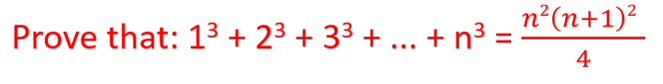

5. Prove that 3 ^{n} > n ² for n = 1, n = 2 and use the mathematical induction to prove that
3 ^{n} > n ² for n a positive integer greater than 2.

Statement P (n) is defined by
3 ^{n} > n ²
STEP 1: We first show that p (1) is true. Let n = 1 and calculate 3 ¹ and 1 ² and compare them
3 ¹ = 3
1 ² = 1
3 is greater than 1 and hence p (1) is true.
Let us also show that P(2) is true.
3 ² = 9
2 ² = 4
Hence P(2) is also true.
STEP 2: We now assume that p (k) is true
3 ^{k} > k ²
Multiply both sides of the above inequality by 3
3 * 3 ^{k} > 3 * k ²
The left side is equal to 3 ^{k + 1}. For k >, 2, we can write
k ² > 2 k and k ² > 1
We now combine the above inequalities by adding the left hand sides and the right hand sides of the two inequalities
2 k ² > 2 k + 1
We now add k ² to both sides of the above inequality to obtain the inequality
3 k ² > k ² + 2 k + 1
Factor the right side we can write
3 * k ² > (k + 1) ²
If 3 * 3 ^{k} > 3 * k ² and 3 * k ² > (k + 1) ² Then
3 * 3 ^{k} > (k + 1) ²
Rewrite the left side as 3 ^{k + 1}
3 ^{k + 1} > (k + 1) ²
Which proves that P(k + 1) is true

6. Prove that n ! > 2 ^{n} for n a positive integer greater than or equal to 4. (Note: n! is n factorial and is given by 1 * 2 * ...* (n-1)*n.)
Statement P (n) is defined by
n! > 2 ^{n}
STEP 1: We first show that p (4) is true. Let n = 4 and calculate 4 ! and 2 ^{n} and compare them
4! = 24
2 ⁴ = 16
24 is greater than 16 and hence p (4) is true.
STEP 2: We now assume that p (k) is true
k! > 2 ^{k}
Multiply both sides of the above inequality by k + 1
k! (k + 1)> 2 ^{k} (k + 1)
The left side is equal to (k + 1)!. For k >, 4, we can write
k + 1 > 2
Multiply both sides of the above inequality by 2 ^{k} to obtain
2 ^{k} (k + 1) > 2 * 2 ^{k}
The above inequality may be written
2 ^{k} (k + 1) > 2 ^{k + 1}
We have proved that (k + 1)! > 2 ^{k} (k + 1) and 2 ^{k} (k + 1) > 2 ^{k + 1} we can now write
(k + 1)! > 2 ^{k + 1}
We have assumed that statement P(k) is true and proved that statement P(k+1) is also true.

7.For any natural number n , n³ + 2n is divisible by 3.
Proof:
Basis Step: If n = 0, then n³ + 2n = 0³ + 2*0 = 0. So it is divisible by 3.
Induction: Assume that for an arbitrary natural number n,
n³ + 2n is divisible by 3. -------- Induction Hypothesis
To prove this for n+1, first try to express ( n + 1 )³ + 2( n + 1 ) in terms of n³ + 2n and use the induction hypothesis.
( n + 1 )³ + 2( n + 1 ) = ( n³ + 3n² + 3n + 1 ) + ( 2n + 2 )
= ( n³ + 2n ) + ( 3n² + 3n + 3 )
= ( n³ + 2n ) + 3( n² + n + 1 )
which is divisible by 3, because ( n³ + 2n ) is divisible by 3 by the induction hypothesis.

- Prove 6^{n}+4 is divisible by 5 by mathematical induction, for n≥0.
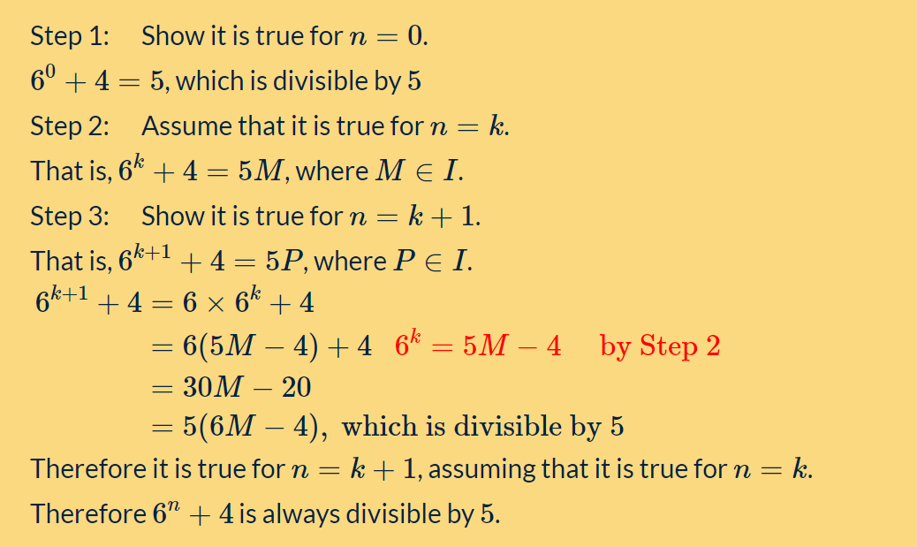

- Prove n(n+2) is divisible by 4 by mathematical induction, if n is any even positive integer.

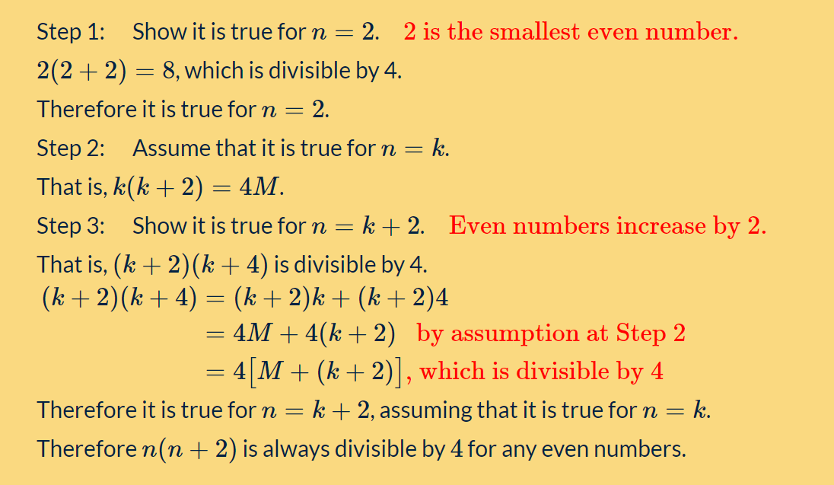

- Prove 5^{n}+2×11^{n} is divisible by 3 by mathematical induction.
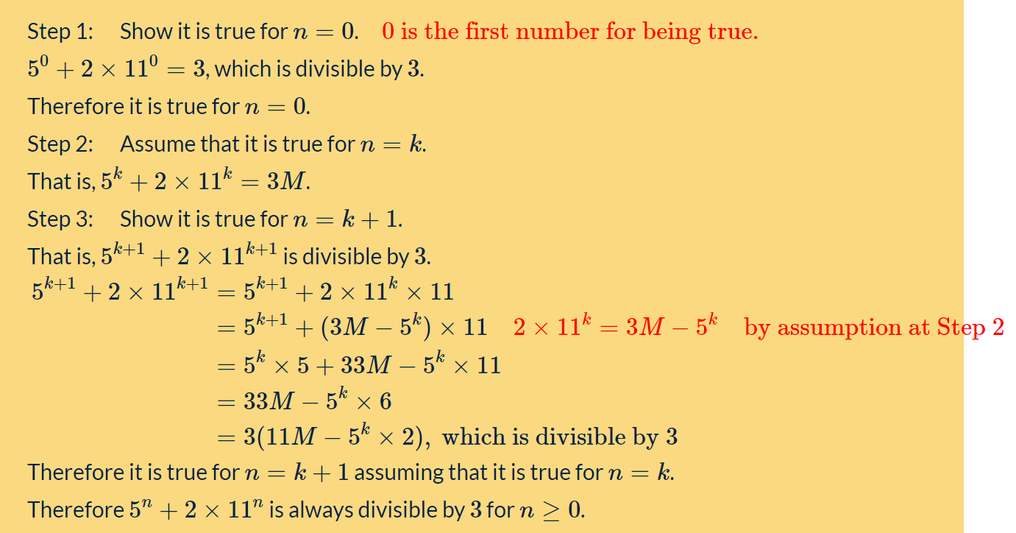

1. By induction prove that n² - 3n + 4 is even and it is true for all positive integers.
Solution:
When n = 1, P (1) = 1 - 3 + 4 = 2 which is an even number.
So P (1) is true.
Now we assume that P (k) is true or k² - 3k + 4 is an even number.
When P (k + 1),
(k + 1)² - 3(k + 1) + 4
= k² + 2k + 1 - 3k + 3 + 4
= k² - 3k + 4 + 2(k + 2)
As k² - 3k + 4 and 2(k + 2) both are even, there sum also will be an even number.
So it is proved that n² - 3n + 4 is even is true for all positive integers.
2. By using mathematical induction prove that the given equation is true for all positive integers.
2 + 6 + 10 + ….. + (4n - 2) = 2n²
Solution:
From the statement formula
When n = 1 or P(1),
LHS = 2
RHS = 2 × 1² = 2
So P(1) is true.
Now we assume that P (k) is true or 2 + 6 + 10 + ….. + (4k - 2) = 2k²
For P (k + 1),
LHS = 2 + 6 + 10 + ….. + (4k - 2) + (4(k + 1) - 2)
= 2k² + (4k + 4 - 2)
= 2k² + 4k + 2
= (k+1)²
= RHS for P(k+1)
Now it is proved that P(k+1) is also true for the equation.
So the given statement is true for all positive integers.

